CODE:
import pandas as pd
import matplotlib.pyplot as plt
roles=['Data Scientist ','Data Engineer ','Data Analyst ',' Business Analyst ','ML engineer']
Count=[100,150,200,250,300]
df=pd.DataFrame(data)
plt.bar(roles,Count,width=0.3)
plt.title('Trends of Data Science Job Postings')
plt.xlabel('Roles')
plt.ylabel('Number of positions')
plt.show()

OUTPUT:
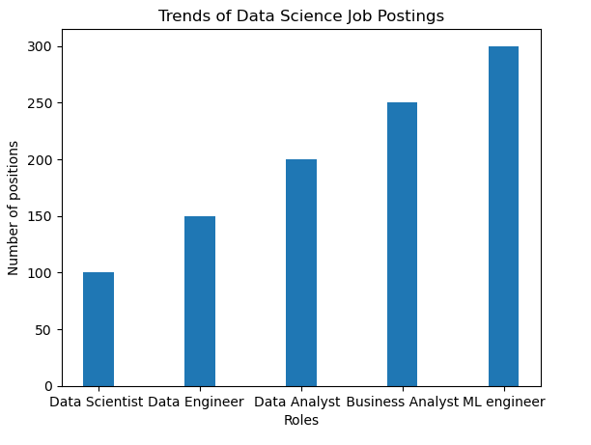
CODE:
import matplotlib.pyplot as plt
roles=["Data Scientist","Data Engineer","Data Analyst","Business Analyst","ML Engineer"]
count=[20,30,17,35,23]
plt.pie(count,labels=roles)
plt.show()

OUTPUT:
